Contents

Create Node JS Application 2

Create Destination in Cloud Foundry (BTP) 4

Consume Node JS service from UI 5

# Create Node JS Application

1. Create a dedicated folder **nodejshome** and another directory inside it called **myapp**
2. To Start the application change to **myapp** directory and execute **npm init** from command line, this will guide you through creating **package.json** file, its recommended to mention entry point as **server.js** (**Note: Through this document, I will take server.js as entry point**)
3. Now create a file called **server.js** (which will act as web server) in **myapp** folder.
4. Before you create an endpoint, download the dependencies and Install Node Packages (Express) – npm install express
5. Create an EndPoint (sayHello) in server.js.

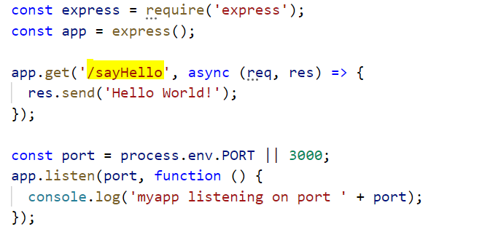

1. Create a **manifest.yaml** file under **nodejshome** directory, this file contains all required information to deploy an application to SAP BTP, Cloud Foundry

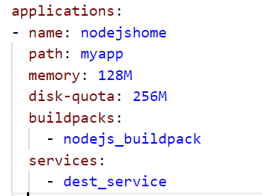

1. You should now have the following directory structure

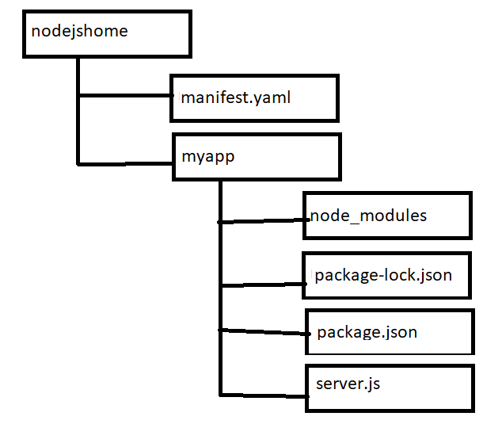

1. Now login to BTP Cloud Foundry environment endpoint (via **cf login**) and execute following command (from command line) inside **nodejshome** directory

**cf push**

1. To figure out application URL, execute command (**cf apps**), from the list locate your app and next to it, you would find the application url

For rest of this document, assume this as the url of the application

**https://zmhirj-nodejs.cfapps.us10.hana.ondemand.com**

1. We need to create a Destination service (mentioned in step 6), execute below command.

**cf create-service destination lite dest_service**

This command tells Cloud Foundry to create an instance of destination service with service plan lite and make it accessible with name (**dest_service**), we now use this name to bind the service to our application, we have already done this part, refer to step 6

# Create Destination in Cloud Foundry (BTP)

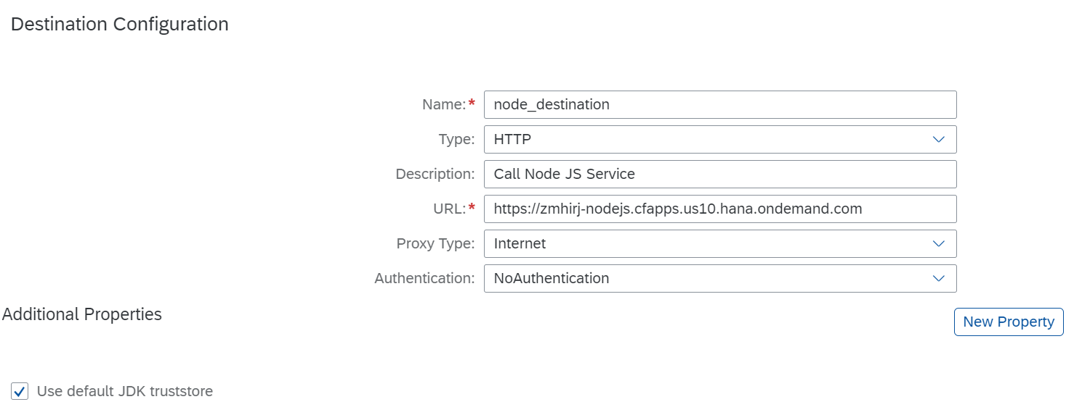

Create a Destination as per above screenshot, For URL, mention the URL from Step 9

# Consume Node JS service from UI

Open xs-app.json and make entry for route as below

{

"authenticationType": "none",

"csrfProtection": false,

"source": "^/ sayHello", **<<This should be the endpoint name, mentioned in node js application>>**

"destination": " node_destination" **<<This should be destination name, created in cloud foundry>>**

}

Note: Make sure route entry is always above the route source ( **"source": "^(.*)$"** ), otherwise it wont get triggered.

Now Make a AJAX call, as below

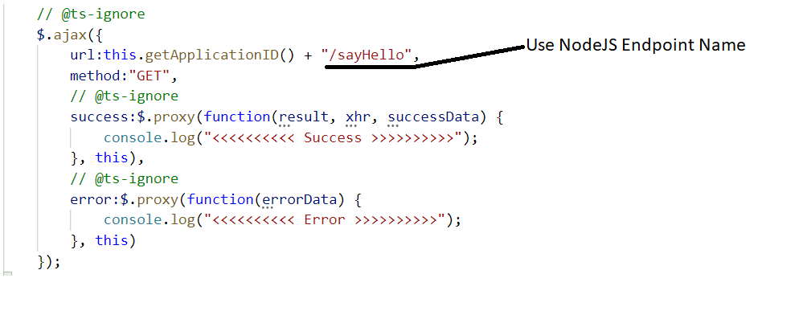

This method returns id mentioned in manifest.json, replacing dots

